

School of Life Sciences

Coaching Scheme

Handbook

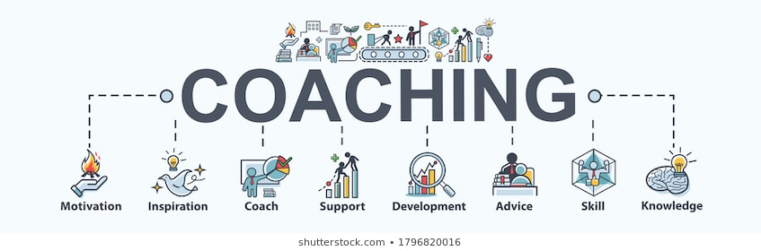

Scheme Organisers:

Champion: Mat Goddard

Administration: Alex Aitken

*This is a voluntary scheme outside of line management and supervision where staff and students support each other.*

**Contents**

|  |  |
| --- | --- |
| Page | Content |
| 3 | What is coaching? |
| 4 | Who can HAVE a coach? |
| 5 | What topics can coaching cover? |
| 5 | Feedback |
| 6 | How the scheme works – how to get a coach |
| 6 | If something doesn’t work out |
| 7 | Who can BE a coach? |
| 7 | Go-To-People |
| 8 | What makes a good coach |
| 8 | How do I become a coach for this scheme? |
| 9 | Information and Guidance for Coaching Sessions |
| 10 | The GROW model |
| 10 | Further Information/Contact Information |

**What is Coaching?**

**Workplace coaching** is a good way to help individuals help themselves. This can be by providing:

* Knowledge
* Skills
* Advice and Training
* Tools
* Opportunities
* Inspiration and Motivation

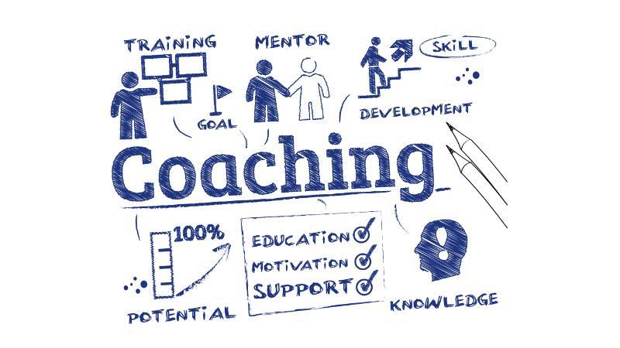

*Image: TrainingJournal.com*

Once equipped and offered support, individuals can move forward and develop independently towards their goals and reach towards their potential.

Coaching in the School of Life Sciences offers the opportunity for staff and students to commit time to themselves, and the chance to bring about improvements which can allow them to grow within their role, becoming more effective and efficient with increased knowledge and skills.

It can build resilience and increase motivation, it can result in progress rather than stagnation, as well as help visualise and make use of opportunities.

Coaching should not be confused with counselling; if you have an issue where counselling is more appropriate or if you are not sure please see

<https://hr-internal.blogs.lincoln.ac.uk/employee-assistance-programme/>

<https://studentservices.lincoln.ac.uk/health-and-wellbeing/counselling/>

**Who Can HAVE a Coach?**

**Everyone** has the opportunity to have a coach.

For undergraduates and MBio students this is with the personal tutoring program.

Everyone else in SLS including

* academic
* professional staff
* postgraduates
* postdocs
* research assistants
* early career researchers

You simply need to look through the information in this handbook and then contact [coachingsls@lincoln.ac.uk](mailto:coachingsls@lincoln.ac.uk) with a request and further information, including a list of available coaches, will be sent.

**

*Image: RichardCorbridge.com*

**What Topics Can Coaching Cover?**

**Anything** so long as there is someone who can help with solutions to your subject matter.

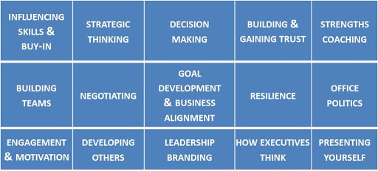

*Image: Laura@insights-to-leadership.com*

Some specific examples could be:

* Time Management
* Career-life balance
* Women in science
* LGBTQ+ or BAME champion
* Interview techniques
* How do I network?
* Career development strategy
* How do I write a grant?
* What makes a good publication?

Sometimes, just a few sessions can be helpful to chat about where you are with everything, why you are there, what can be improved, what should be side-lined, what are the priorities. Or sometimes a longer set of sessions may be appropriate, where ongoing guidance or support is required.

**Feedback**

**Continuous Improvement** for the scheme and for individuals (coaches and those being coached), can be attained though feedback from which the scheme can be amended and developed further. Therefore, a requirement of engaging with this scheme is that you provide feedback on your experience.

This will be in the form of 5 tick-box questions with optional free text sent to you a couple of times during the coaching.

In addition to your feedback forms you can also leave anonymous feedback and comments by posting something in the School of Life Sciences “Comment Box” which is in JBL reception opposite the main desk.

**How the Coaching Scheme Works – How to get a Coach**

1. Names of staff and students who are currently available to be a coach can be sent to you on request, please email [coachingsls@lincoln.ac.uk](mailto:coachingsls@lincoln.ac.uk)
2. If you would like a coach you need to look through this handbook and if this scheme is suitable for you, email [coachingsls@lincoln.ac.uk](mailto:coachingsls@lincoln.ac.uk) with the following information:
   1. The name of the coach from the list in [1] above or say you don’t mind.
   2. The topic you would like to cover. If this is confidential please just put confidential.
   3. When you would ideally like the coaching to start.
3. The scheme organisers will then be in touch.
   1. The coach will be contacted and if they are available introductions will be made via email.
   2. Both will receive an introductory email and a simple coaching agreement.
   3. Initially the coaching will be presumed to run for 6 months unless a different timeframe has been requested/is appropriate.
4. After coaching has commenced and towards the end (or at about 6 months), you will both be sent the brief feedback form to complete and return.

**What if Something Doesn’t Work Out?**



*Image: 3nions*

If as a coach, or someone who is receiving coaching, you find that this isn’t working for you for whatever reason, you can cancel any future sessions straight away by politely letting the other person know. Please contact the Scheme organisers if you need help with this.

Pairing of people for coaching doesn’t always work out and neither side should take any cancelled coaching personally – it is often that personalities are not such a great fit.

If you do wish to stop the coaching before the end of the contract, please email [coachingsls@lincoln.ac.uk](mailto:coachingsls@lincoln.ac.uk) and let us know that your coaching has finished, you do not need to tell us why. If you were the person being coached and would like to restart with someone else then this is fine, just let us know.

**Who can be a coach?**

**Anyone** who has some useful knowledge or experience and can dedicate a set amount of time.

This includes any postgraduate students who are in a good position to offer coaching to their peers or to newly arriving students in order to help them gain the best from the PGR community and their studies.

If you are able to support this scheme and offer coaching to others, please see page 8 for information on what you need to do.

**Go-To-People**

**In addition** to the more traditional coaching, this scheme also hopes to offer a quick solution to simple questions where a series of “go-to” people or “experts” who would help at a basic level with general hurdles people find within school, e.g.

* Who is the best person to help with Blackboard?
* Who would you ask about UoL wide contacts (e.g. press office)?
* Who can train me on TechOne?
* Who can help me with Health & Safety?
* What do I need to do for ethics?

To receive a list of current Go-To-People please email [coachingsls@lincoln.ac.uk](mailto:coachingsls@lincoln.ac.uk)



*Image:Blog.tdsbusiness.com*

Could you be a Go-To-Person? Do you have a bit of specific knowledge that could be helpful? If so and you are happy to join our directory please email [coachingsls@lincoln.ac.uk](mailto:coachingsls@lincoln.ac.uk)

**What Makes A Good Coach?**

* Basic level of people skills, empathy and patience with active listening (don’t interrupt) & confirmation.
* A willingness to dedicate time to help others.
* Appreciate your main role is to listen, not talk.
* Integrity and objectivity with the ability to stand back – it’s not your issue.
* Impartiality – advice can be based on experience, but it is not about what you would do, it is about offering a range of possibilities. You’re not there to provide a solution/answer, but to help the person being coached to find the solution/answer.
* Effective Communication and Facilitation (not telling, not doing).
* Focus on the agenda – offer suggestions based on facts or evidence of success.
* Confront the Elephant; if you think something isn’t being said, address this appropriately.
* Know your coaching limits:
  + How much time and energy do you have? Do not over-commit to too many people, once you are at capacity, let the scheme administration know so that your name can temporarily be removed from the “available coaches list”.
  + Know who to go to if you need assistance.
    - This **must** retain confidentiality and not share information from coaching sessions without permission, just asking a colleague might lead to later negative judgements of the person you are trying to help.
    - Initially the scheme sponsor, Mat Goddard, would be useful for issues or the scheme administrator, Alex Aitken, who has a qualification in coaching for practical advice.

**How Do I Become a Coach for this Scheme?**

It can be helpful to take a few minutes to consider the following:

* What are you successful at?
* Identify your skill set
* Know your knowledge base (and know what you don’t know)
* What is your relevant experience?

*Think about how up-to-date this is – e.g. if you were successfully getting grants 10 years ago but not now, someone with recent success would be more appropriate for coaching on grant applications.*

Huge experience is not necessary, good, relevant experience, which is useful to someone with less experience is what is helpful. 1-2-1 sessions for practical advice on how to be an effective coach can be arranged if you would find this helpful.

If you would like to put your name forward please email [coachingsls@lincoln.ac.uk](mailto:coachingsls@lincoln.ac.uk) with a few words on what topics you could offer coaching on, if you are unsure please speak with Alex Aitken who will be able to help.

**Information and Guidance for Coaching Sessions**

**Confidentiality**

It may not seem especially important in all instances, but **keeping the nature of your coaching conversations confidential is imperative**. Not everyone will be comfortable with others knowing they are asking for a bit of guidance, and not everyone will want their advice passed on without their agreement.

**Reliability**

As a participant in this scheme you will need to be able to reliably commit time to agreed meetings and complete agreed actions by agreed dates.

You should be prepared to be honest and open whilst remaining professional. You should also be realistic about what you are seeking and about the possible outcomes. Coaching is not about finding a solution or fixing a problem, it is about equipping individuals to help themselves in a constructive manner.

You should both remain focused and not ramble off on tangents. If something extra and interesting comes up, it can be more useful to consider parking this for another time and keep the topic of the day.

**Timescale**

The coaching timescale is up to you both to define, however it is best to put an end point in place for when coaching will be completed as this gives focus and prevents the coaching becoming a habit that takes up time rather than the useful series of meaningful meetings it is supposed to be.

A guide would be that coaching should be structured over no more than 6 months, but of course this can be extended by mutual agreement if required.

**Meeting Frequency**

The frequency of meetings is up to you both to define and these do not have to be regular, however they would ideally fit with any actions which have been agreed, for example a coach may say they will find information in a week, so meeting again in a week would be obvious, or if you are being coached and have some reading or investigating to do, it might be that you need a month to do this adequately.

Meetings can be regular or as required but generally you would always agree the next meeting date during the current session.

**Meeting Length**

The length of the meeting is also something which you will define based on needs and other demands on your time. An hour is probably the maximum a session should run otherwise the content can be onerous to recall or action.

**Record Keeping**

It is a good idea to keep some notes on the useful content of sessions and to record any agreed actions and deadlines. This can be done throughout the session or towards the end when a recap would be a good conclusion.

**Outcomes**

Coaching should be a positive and stress-free experience. It will hopefully meet the ambitions of the initial remit, but you should accept that the genuine outcome may not be the desired outcome. For example, “success with grant writing” may be sought but the reality might be that while “improved grant writing” could be achieved, it does not guarantee success.

**Session Structure**

It is always good to have a topic to discuss or agenda to follow. Additionally, many models exist to support coaching, and these can direct the process and provide a map to follow. This keeps focus and results in a conclusion.

One simple and popular example is the **GROW model.**

**G** – what is the **G**oal of this coaching?

**R** – what is the **R**eality of what you are seeking to achieve?

**O** – what are the **O**ptions you can pursue (also consider **O**bstacles to achieving the goal)

**W** – what **W**ill you do to achieve your goal? Specific actions, how you will focus and maintain positivity.

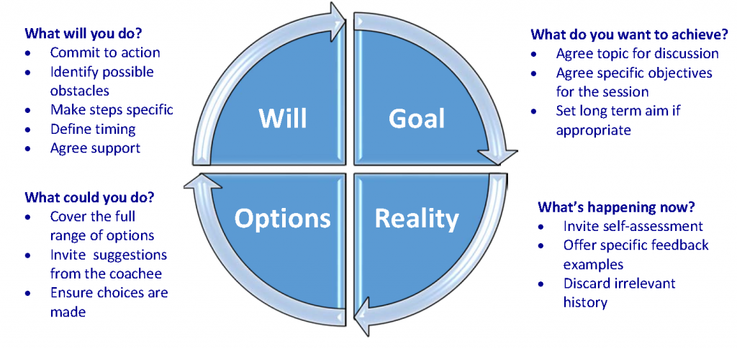

**Further Information**

Please contact [coachingsls@lincoln.ac.uk](mailto:coachingsls@lincoln.ac.uk) or directly email Mat Goddard or Alex Aitken with any queries.